Summer Schedule
Summer Schedule (Garbobot-Land and water sensor):
Assigned Date | Estimated Completion Date | Person | Task | Progress | Status
Week 1  (June 14-20) | Week 1 Sunday | Andy, Shreyas, Daniel | Research the doability and cost of each module. Finalize and draw system block diagram of the first rev product.  Defining the goal for each subsection (water sensor, garbobot-land subcomponents) | Garbobot Tasks and Progress | In progress
Week 1 | Week 1 Sunday | Daniel | Research solutions for waterproof casing. Draw a rough mechanical design; then start designing soft tissue gripper if applicable | Daniel: Washing machine sensor that detects how dirty the water is!! (turbidity sensor) | not started
Week 2 | Week 2 Sunday | Andy, Shreyas | find component for pH sensor and oxygen sensor both with probes, put together a schematic |  | not started
Week 3 | Week 2 Sunday | Andy, Shreyas, Daniel | Verify Daniel’s preliminary designs. Daniel then makes modifications. Start CAD models of the casings and the gripper |  | not started
Week 4 | Week 4 | Andy, Shreyas | find components for temperature sensor and make a schematic. Find usable bio sensor parts |  | not started
Week 4 | Week 4 | Daniel | Continue CAD model |  | not started
Week 5 | Week 5 | Andy, Shreyas |  |  | not started
Week 5 | Week 5 | Daniel

Assigned Date | Estimated Completion Date | Person | Task | Progress | Status
2/18/26 | 2/21/26 | Shreyas | Research how to make a robotic arm ROS2 package. Create a ROS2 workspace for a simple robotic arm of 2 joints. Screenshot progress | Screenshot:  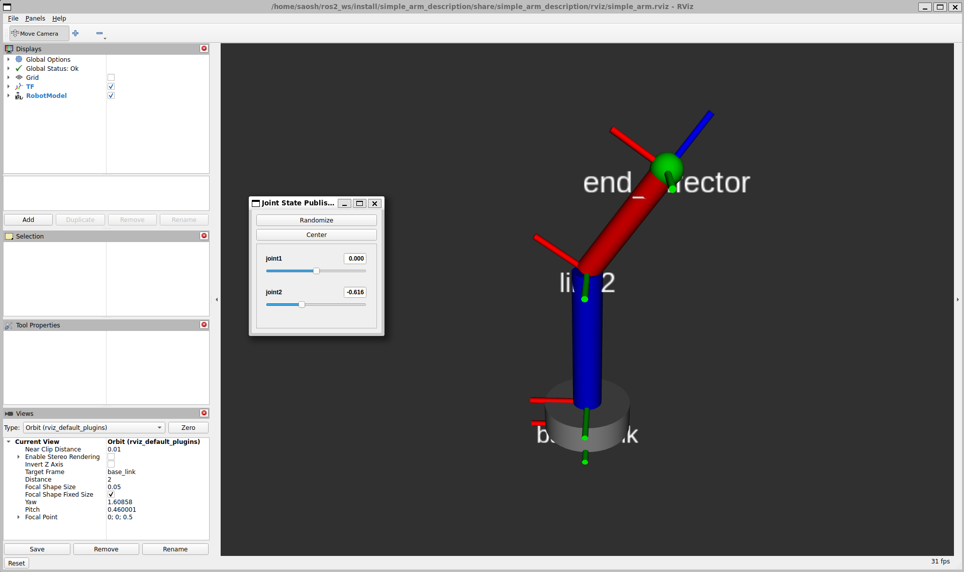  Description:  Two joint arm with variance on left and right and can spin in a 360 direction | Complete
2/18/26 | 3/2/26 | Andy | Established ROS2 connection between a physical motor driver and LIDAR sensor connected to Jetson | Description: this is a task I’m working on in my research lab which directly contributes to what we’re building | Handed to someone else in the ARC Lab, will ask for the code later to use on this project.
2/23/26 | TBD | Andy + Shreyas | Install a current sensor to the robot and program it to enable current readings of the entire electronic system  Andy - bring ESP32 and INA226 breakout board to meeting with Shreyas | Description: use Arduino IDE with ESP32 and a INA226 breakout board (already acquired) | started
2/23/26 | 3/2/26 | Shreyas | Make a simple box with four wheels in RVIZ and put the already existing arm on top. Link the two of them | Screenshot  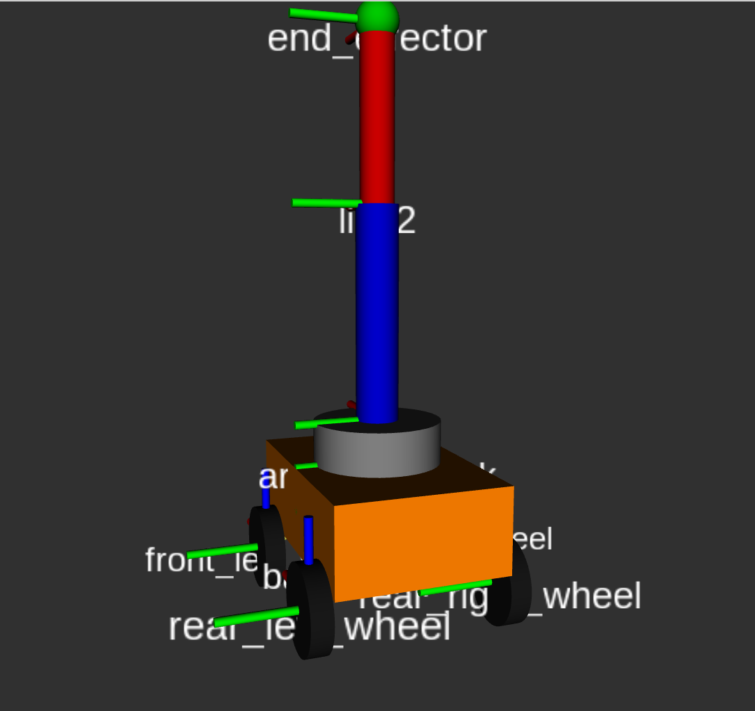 | Complete
3/2/26 | 3/18/26 | Shreyas (&Andy) | Make a PCB spec for a sensor of your choice, interface it with STM32. Needs to have I2C.  Start schematic doc for it in KiCad -> look at the chip in the document and follow STM YT vid  Sensor options: camera, IMU, current, force, range | document link:Sensor Board Spec - Shreyas | Andy: successfully breadboarded and programmed the GPS using a ESP32, was able to get accurate coordinates, but the lock time is too long, an IMU is needed to sense motion and provide faster location response.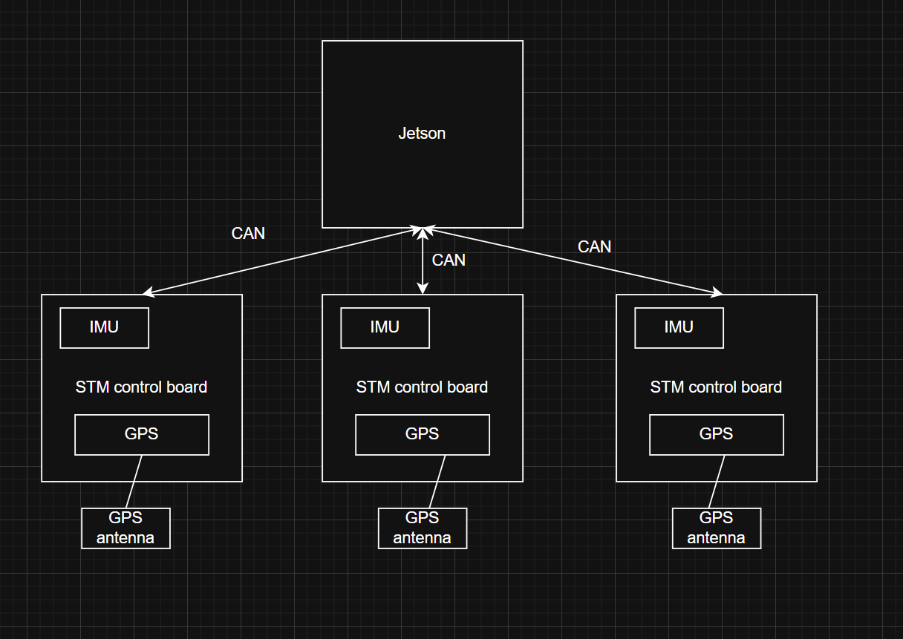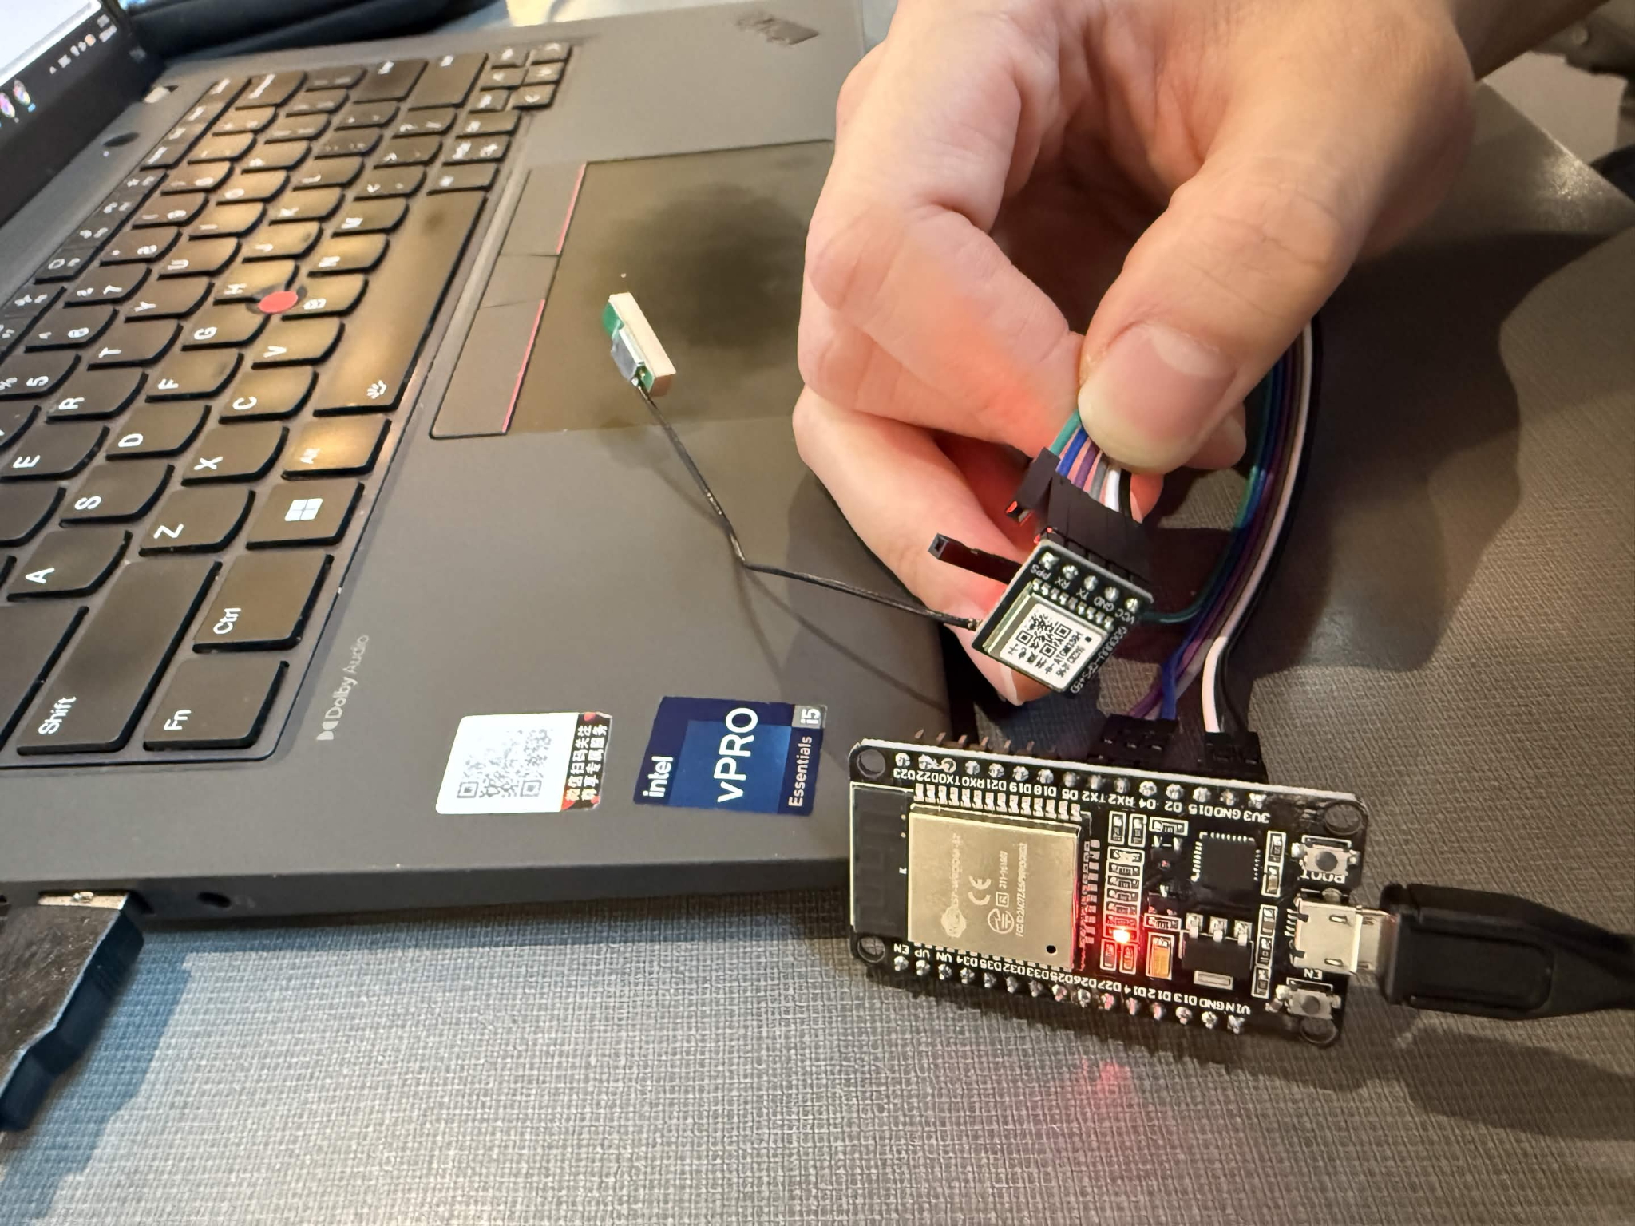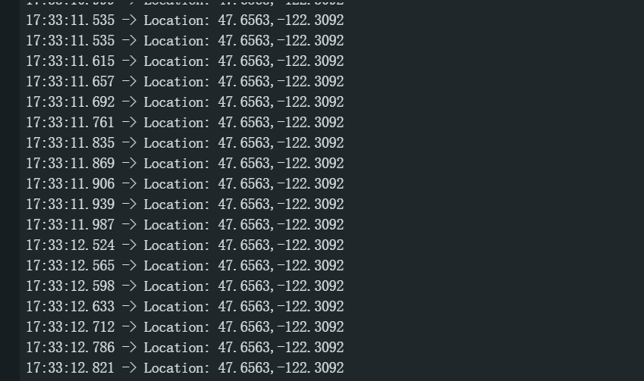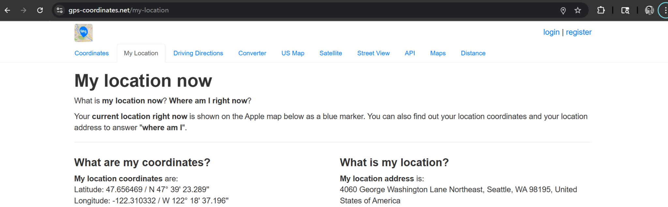
2/23/26 | 3/30/26 | Shreyas | Learn how to design around a microcontroller (STM32) and use it to interface with a sensor. Fabricate the board and code it to read all the data | Image of working board  tutorial from Phil’s Lab: https://youtu.be/aVUqaB0IMh4?si=26_mtlfAtesHz-LI | Not Started (do it over break)
4/24/26 | End of quarter | Andy and Shreyas | Research water quality solutions and write spec for water quality evaluation/monitoring and deployable underwater cleaning vehicle

System Block Diagram
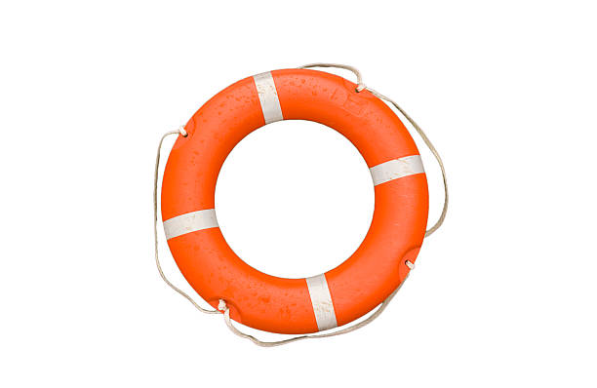

waterproof shell
MCU
Pressure Sensor
IMU

Oxygen Sensor

Possible Shape: Buoy and water sensor box in the middle

